7.0.16 Editors - 3D View - Grease Pencil object - Weight Paint Mode - Brushes context menu
Weight Paint Mode - Brushes Context Menu 1
Radius 1
Strength 1
Weight 1
Active Layer 2
Layer dropdown box 2
New Layer 2
Layer Edit Box 2
Remove Layer 2

Weight Paint Mode - Brushes Context Menu

Call this menu with double right click in the 3D viewport. You need to be in Weight Paint mode with a grease pencil object.

In Weight Paint mode you will call a context menu with the sliders from the Brush settings.

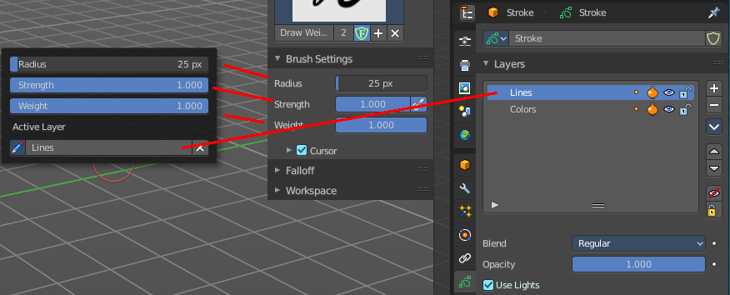

Radius
The radius of the sculpt brush.

Strength
The strength of the sculpt brush.

Weight
The vertex weight to paint to.

Active Layer
The active grease pencil layer. You can choose another layer, and add new layers here too. It is the same content than in the Properties editor.

Layer drop down box
The list of available layers.

New Layer
Add a new grease pencil layer.

Layer Edit Box
The currently active grease pencil layer. Rename it by clicking into the field.

Remove Layer
Remove the grease pencil layer.

